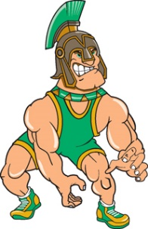
7th Annual

South Torrance

“Spartan Season Kick-off”

Varsity 24-Man Wrestling Tournament

Where: South Torrance High School
4801 Pacific Coast Highway
Torrance, CA 90505

When: Saturday, November 20th, 2021

Weigh-Ins: 7:00 am in the gym

Wrestling: Begins at 9:00 am on 5 Mats
Three 2-minute periods.
24 man double elimination.

Fee: $350.00 per team. Make checks to South Torrance Wrestling
Mail Contracts and checks to:
South Torrance High Wrestling
C/O Wrestling
4801 Pacific Coast Highway
Torrance, Ca 90505
Awards: 1st – 4th Team Trophies
1st, 2nd, double 3rds, double 5th and double 7th medals
Outstanding Wrestler Award

All Day Coaches Hospitality Room!!

Snack Bar will be available

For further info call Tournament Director Don Garriott

Cell (310) 749-5480

E-mail dgarriott@cerritos.edu

Last tournament had 70 CIF Place winners, 14 State Qualifiers and 4 State Place Winners

